**Data** : Raw and isolated facts about an entity and record.

**Information** : Processed, meaningful and reusable data

**Database** : Collection of similar type of data

**DBMS** : Software used to manipulate database

**Disadvantages of File System :**

* **Data redundancy :** Same data is kept at multiple places
* **Data inconsistency :** Same data with different values at different places
* **Difficulty in accessing data**
* **Data isolation**
* **Security problem**
* **Atomicity problem**
* **Concurrent anomalies**
* **Integrity problems**

**Types of Database :**

* **OLAP (Online Analytical Processing)**
  + Historical Data
  + Subject Oriented
  + Decision Making
  + (95% old data)
* **OLTP (Online Transaction Processing)**
  + Current Data
  + Application oriented
  + Day to day operations
  + (5% new data)

**ER Diagram :**

It is a non-technical design method works on conceptual level based on the perception of real world. It consists of collection of basic objects called entities and of relationship between these objects.

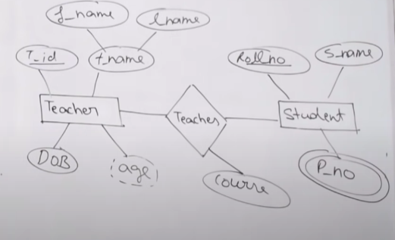

**Entity :**

An entity is a thing or object in a real world that is distinguishable from other objects based on the properties it possesses. It can be of two types:

* Tangible : Entities which physically exist in the real world e.g Bank Locker
* Intangible : Entities which does not exist physically in the real world. E.g Account

**Entity Set** : Collection of similar types of entities

**Attributes :** It is the unit that describes the characteristics of entities.

* Simple-Composite : Simple can’t be divided further, but composite can be divided further
* Single-Multivalued : Single having one value only but multivalued can have a number of values
* Stored-Derived : Stored i.e how value is stored in the database & Derived i.e how value is computed in the database

**Relationship :** It is an association between two or more entities of same or different entity set. There is no representation in E-R diagram because it is an instance or data. It can be represented in relational model either using row or table

**Relationship Set** : A set of similar type of relationship

Any relationship has three components

* Name
* Degree
* Cardinality Ratio/Participation Constraints

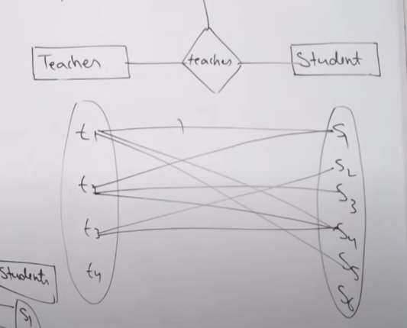

**Degree of Relationship Set :** It signifies the number of entities participating in the relationship.

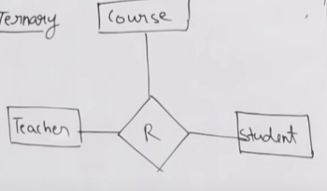

**Cardinality Ratio** : It expresses the number of entites to which other entities can be related via a relationship.

* 1 : 1 – One entity can atmost related to one entity of other type in a relationship
* 1 : N – One entity can atmost relate at most N entity of other type in a relationship or vice versa N entity can atmost related to one entity in other way round.
* N : 1
* M:N

**Functional Dependency**

If there is a functional dependency between A to B , it means , with A , we can search the value of B.

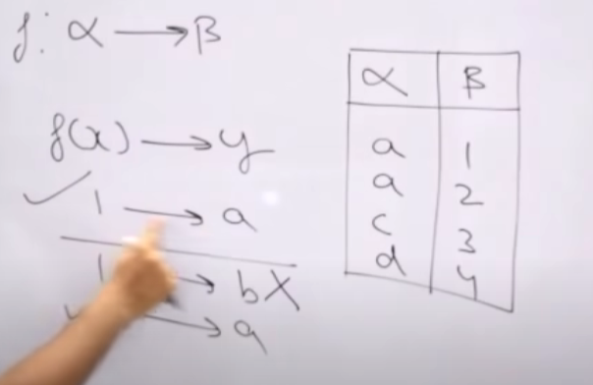

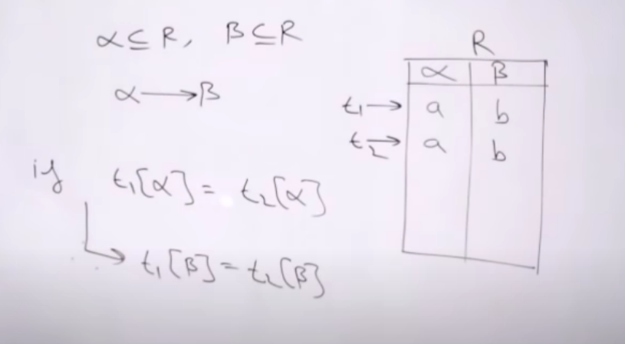

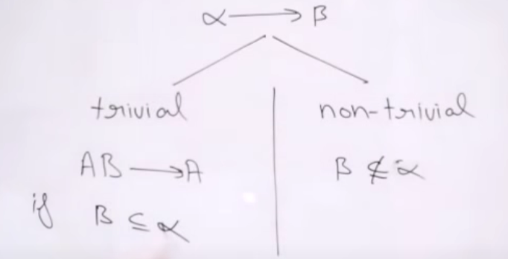

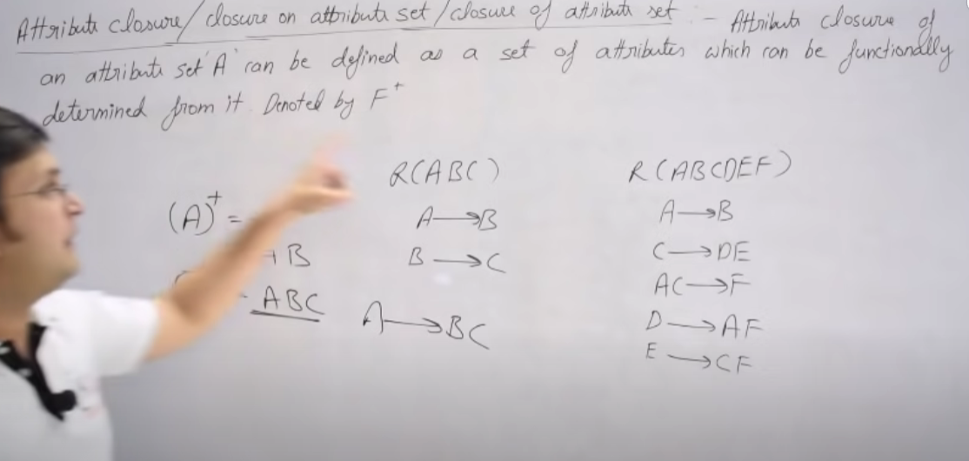

**Armstrong Axiom :**

It holds on every relational database and can be used to generate closure set.

**Primary Rules :**

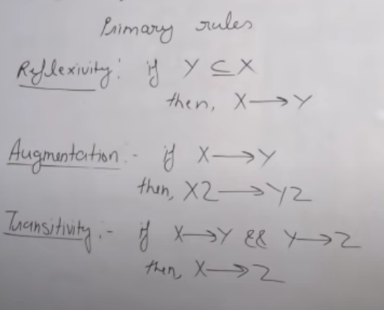

**Secondary Rules :**

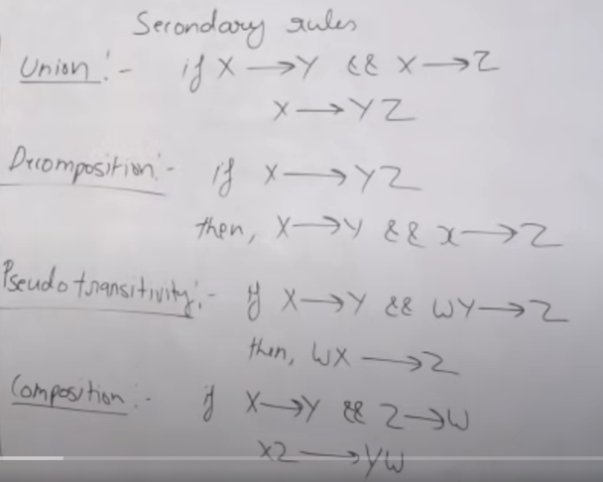

**Equivalence of Functional Dependency :**

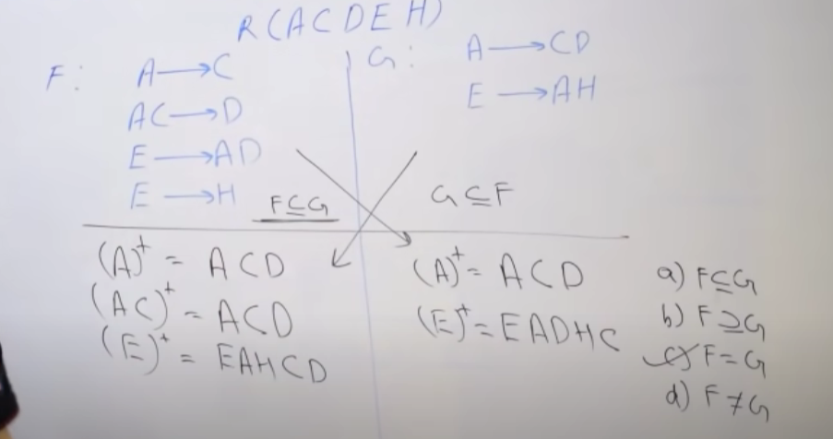

**Canonical Form or Irreducible form of Functional Dependency :**

* Checking for RHS
  + If the closure of a functional dependency is same with or without it, then it means it is redundant.
* Checking for LHS
  + First the closure is computed with the functional dependency, after that we split it and check the functional dependency, if any thing is same, it means that functional dependency is redundant.

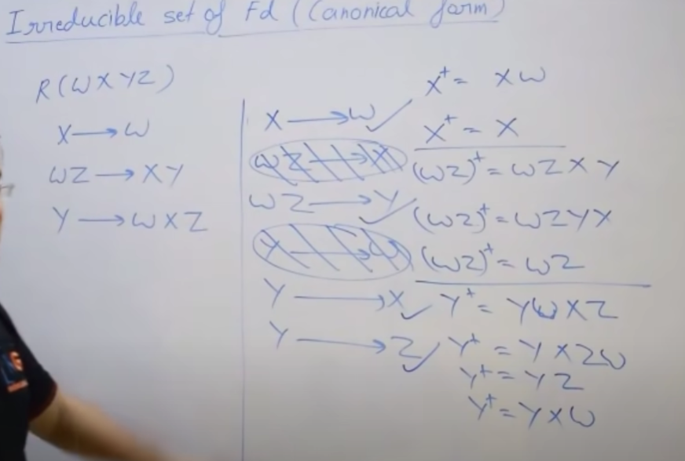

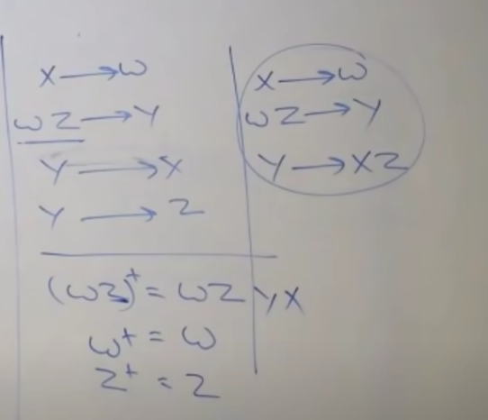

**Keys :**

* **Super Key :** The set of attributes which are required to uniquely identify a tuple or row is called super key.
* **Candidate Key :** The minimum set of attributes which are required to uniquely identify a tuple or row is called candidate key.
* **Primary key :** There can be a number of candidate keys , so we can choose any candidate key and that will be primary key for a table.
* **Foreign Key :** If an attribute can take only those values which are present as values of some other attribute , it will be a foreign key to a attribute to which it refers.

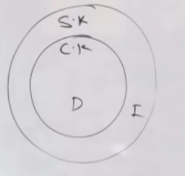

**Finding Candidate Keys:**

We will first choose those attributes for which we don’t have any incoming edges, those attributes will be considered as essential attributes. After that we’ll try to making groups and check if we can find the entire closure or not. If we can find the entire closure with small group only, then we don’t need to go for larger group as they will fall in the group of super keys.

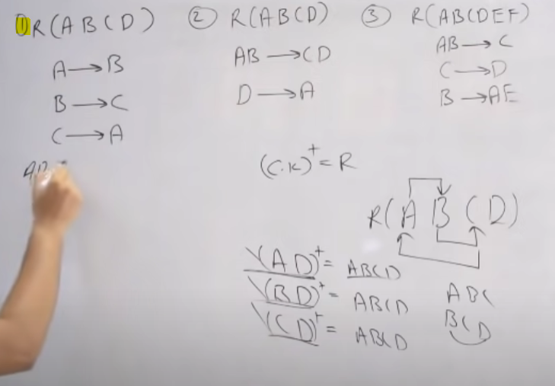

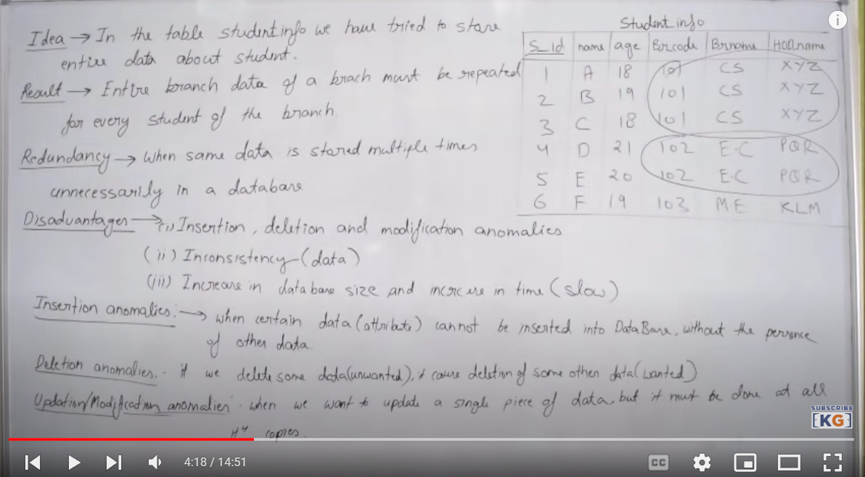

**Normalisation :** It is a process to decompose a table into multiple tables having only main data about the entity. It is basically used to remove redundancy, insertion , deletion and modification anomalies, inconsistency and increase in database size and time.

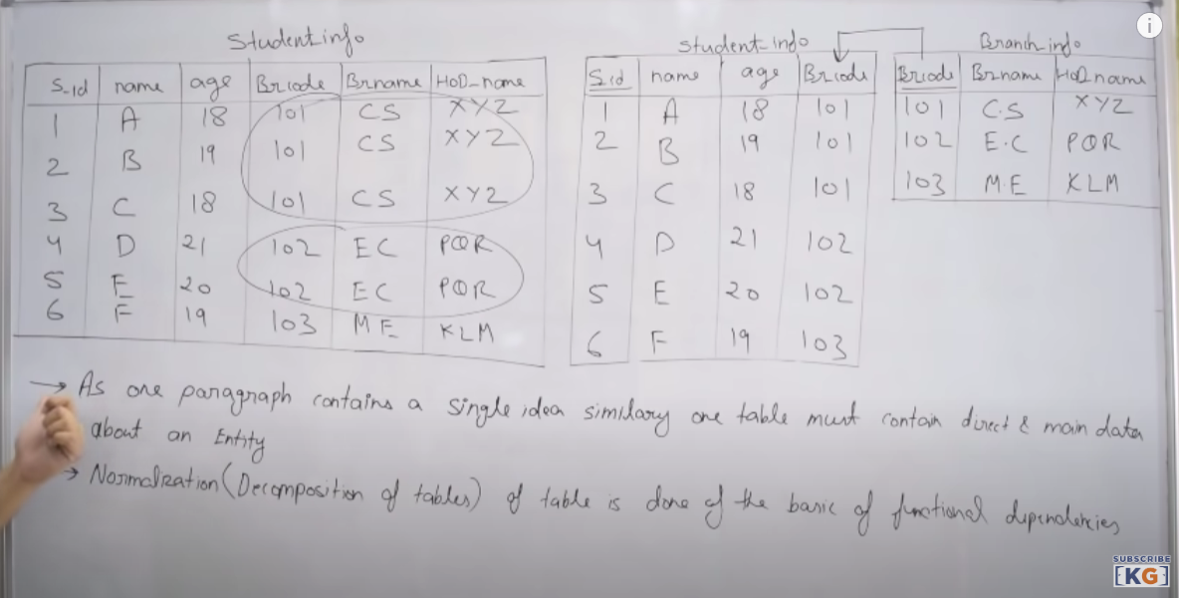

**1NF**

* There are only single values attributes.
* Attribute domain doesn’t change (Name column always contains name only)
* There is a unique name for every attribute/column
* The order in which data is stored doesn’t matter.

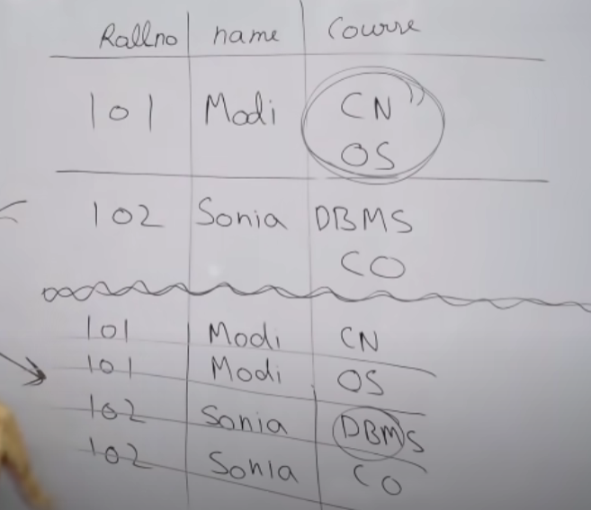

**2NF**

* The table should be in 1NF
* There should not be any partial dependency

Prime Attributes : Those attributes which are part of any candidate key, are called prime attributes.

Non-Prime Attributes : Those attributes which are not part of any candidate key, are called non-prime attributes.

There shouldn’t be any partial dependency because partial dependency ensures that without the value of other attribute in a candidate key, the column can’t be found, even if other attribute is present, which is contradiction to the concept of candidate key.

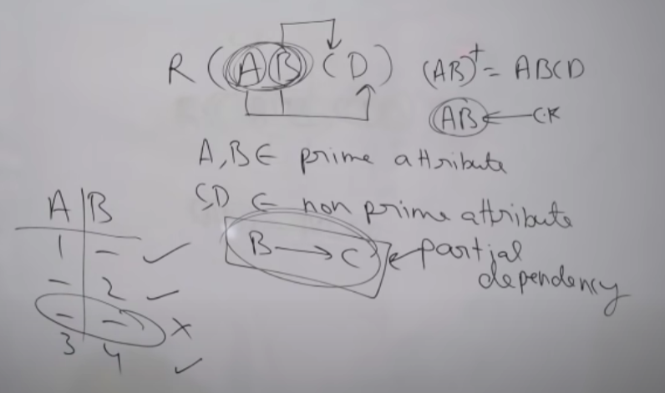

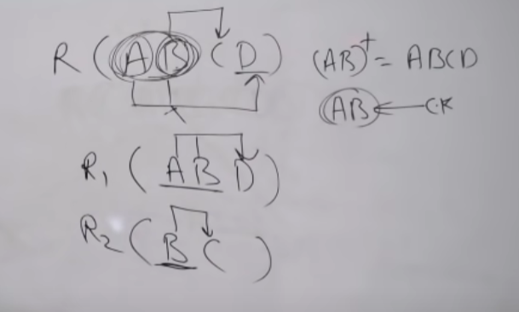

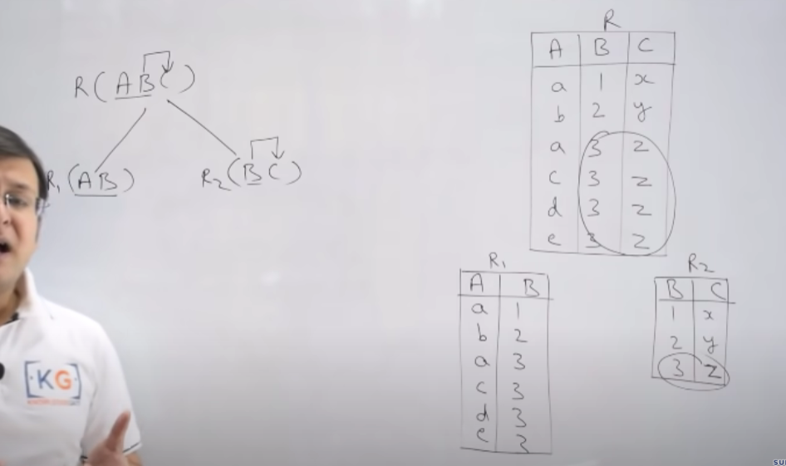

We should always have one column in common because else the join and composition will be lossy.

**3NF**

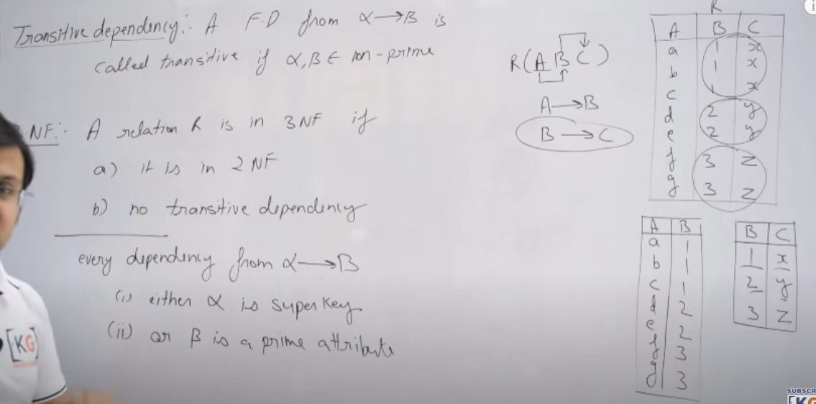

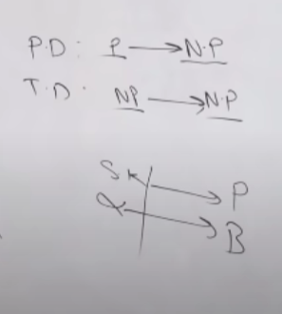

**BCNF**

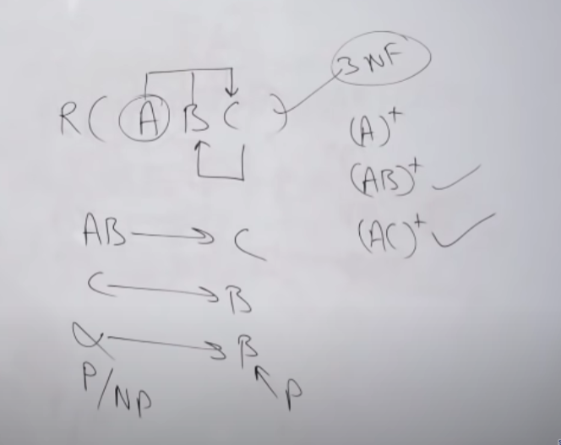

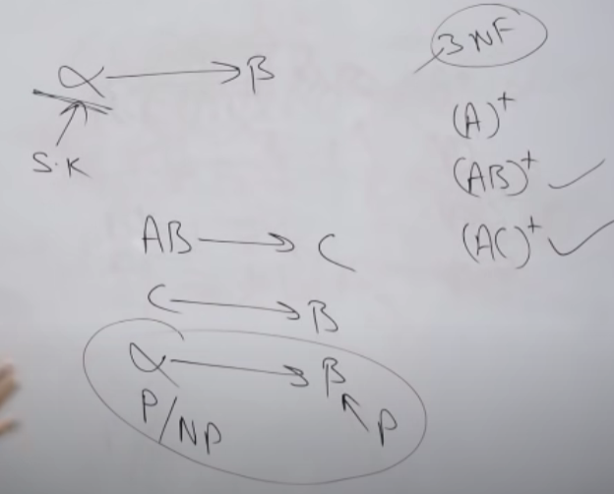

**Lossless join decomposition/Non additive**

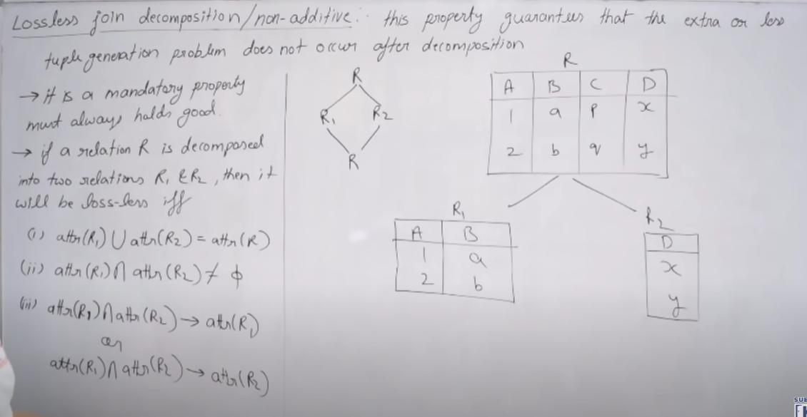

The third point says that the common attribute should be candidate key i.e it should find all the attributes either in R1 or R2.

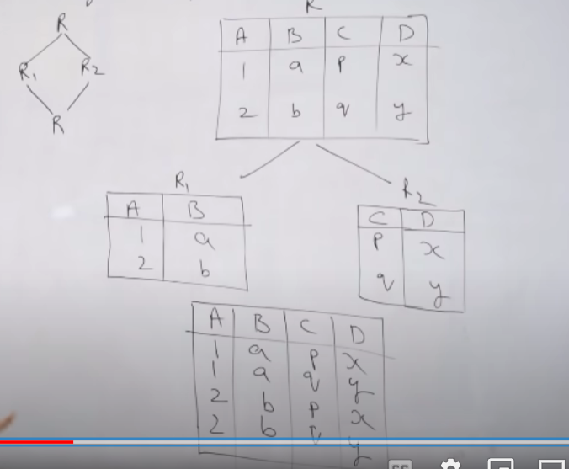

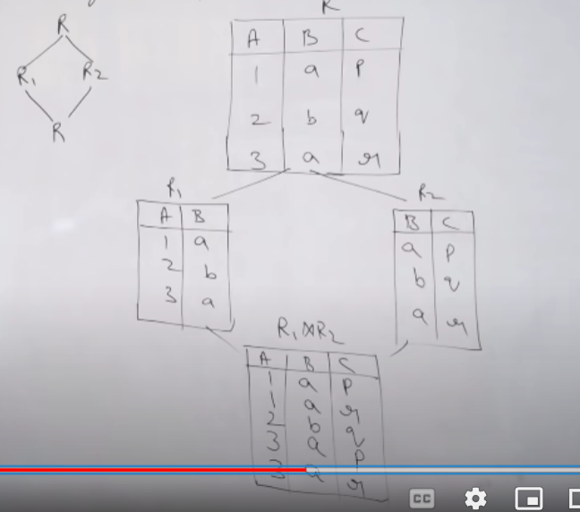

**Indexing :**

Indexing is the way to optimize the performance of the database by minimizing the number of disk access required when a query is processed. It is a data structure technique which is used to quickly locate and access the data in a database.

Indexes are created using a few database columns :

* Search Key
* Data Reference

**Sparse Indexing:**

It is a type of indexing in which we have records for only unique items in a data file. There is a possibility of duplicate data but we will put only unique records in the index file.

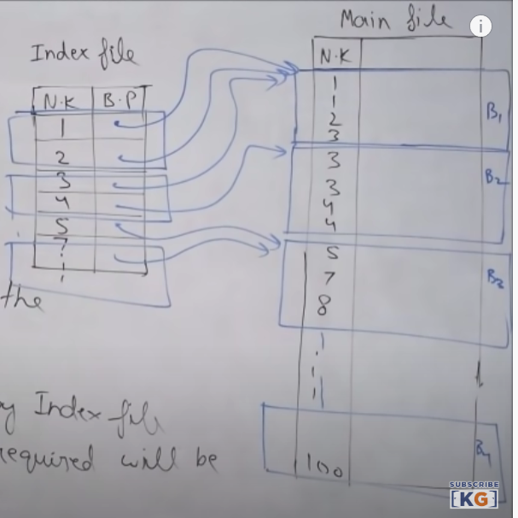

**Dense Indexing :**

It is a type of indexing in which we have each record from file in the index file.

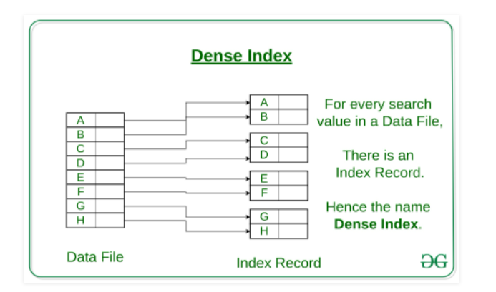

**Primary Indexing :**

* Main file sorted
* Primary Key is used as anchor attribute
* Example of Sparse Indexing
* No of entries in index file = No of blocks in the data file
* No of access required = (log n + 1 ) i.e 1 is for access from block pointer from index to main file

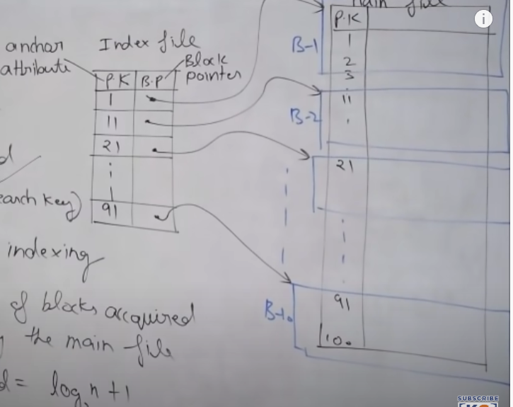

**Clustering Indexing :**

* Main file is sorted(on some non-key attribute)
* Non-key is used as anchor attribute
* It is both example of sparse and dense indexing (there will be one entry for each unique value of the non-key attribute)
* No of access required >= (log n + 1)

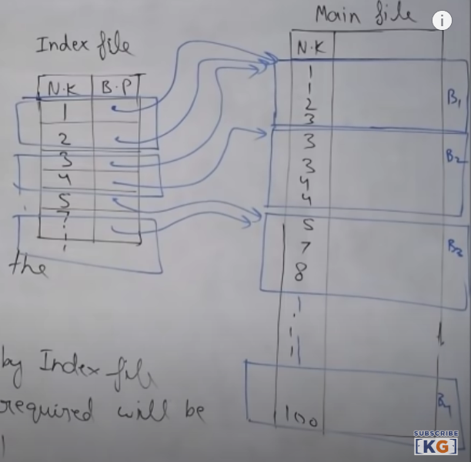

**Secondary Indexing :**

* Main file unsorted
* Can be done on key as well as non-key attributes
* It is called secondary because normally primary indexing is already done
* It is an example of dense indexing
* No of entries in index file = no of entries in main file
* Total disk access = (log n + 1)

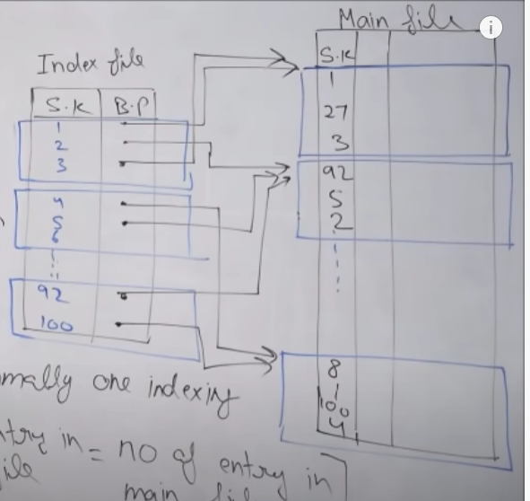

**Transactions :**

A transaction is a bundle of instructions which perform a logical unit of work.

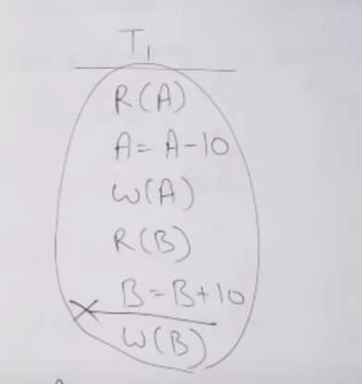

A transaction has 4 properties :

1. Atomicity : Either a transaction will occur or not occur.
2. Consistency : The database will always be consistent before or after the transaction.
3. Isolation : One transaction is always isolated from another transaction.
4. Durability : Once a transaction is committed, it’ll always be there even in the event of power losses and errors.

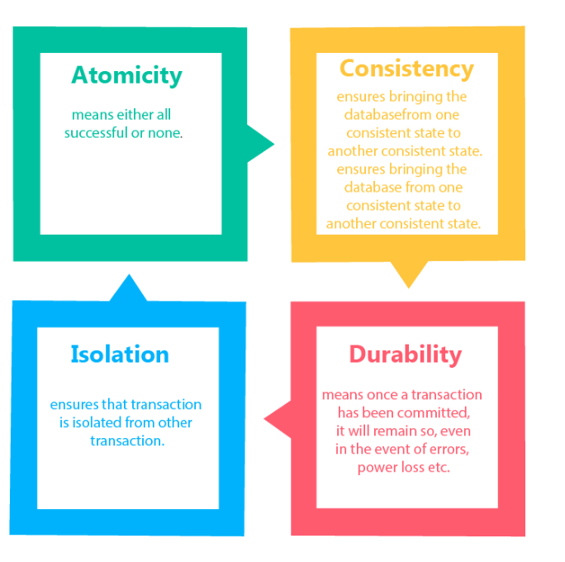

**Transaction States in DBMS**

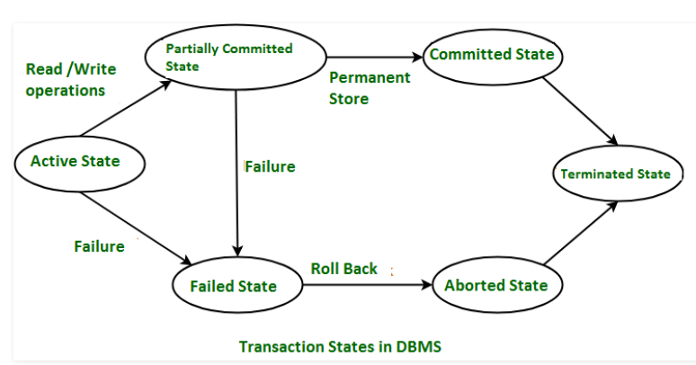

**Active State :**

When the instruction of the transaction is running, then it is called active state. If all the read and write operations are performed without any error, then it goes to the partially committed state.

**Partially Committed :**

All the read and write operations are initially done in the local buffer, hence, it’ll be in the partially committed state.

**Committed State :**

It is the state when the changes are made permanent to the database.

**Failed State :**

When any instruction of the transaction fails, it goes to the failed state.

**Aborted State :**

After having any type of failure, the transaction goes from failed state to aborted state and since the previous changes are done in local buffer, hence, these changes are deleted or rolled back.

**Terminated State :**

If there isn’t any rollback or the transaction comes from the committed state, then, the system is consistent and ready for new transactionand old transaction is terminated.

**Advantages of Concurrency :**

* Waiting Time : It may be defined as the total time a transaction has to wait in case of concurrency (multiple transactions working at a single time ) (LOW)
* Response Time : It may be defined as the total time taken for the first response.(LOW)
* Resource Utilization : It may be defined as the limit to which resource should be consumed in case of concurrency.(HIGH)
* Efficiency : It may be defined as the total efficiency in case of concurrency.(HIGH)

**Dirty Read Problem :**

When dependent transaction is committed before the commit of the independent transaction and reads the data from the local buffer, then , it is called dirty read. In other words, when one transaction reads the data from some other transaction , which is having value of uncommitted changes from local buffer , then, it is called dirty read.

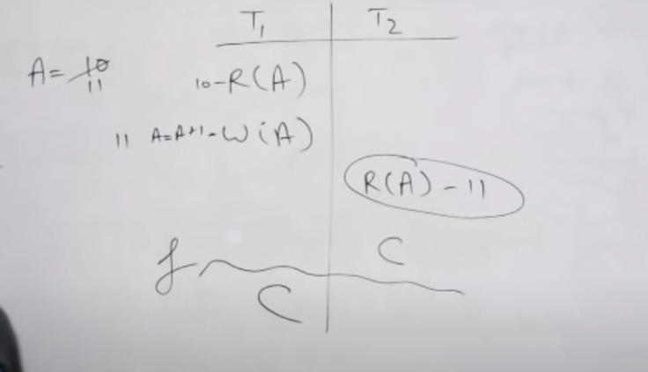

The solution to this problem is always commit after independent transaction so that if in any case there is any failure and data is rolled back, in that case, the dependent transaction would have the chance to roll back.

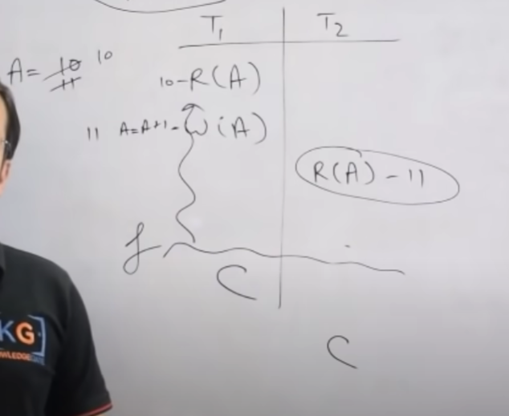

**Unrepeatable Read Problem:**

When two transactions are running at a single time, and one transaction reads the value of a variable from other transactions, if at two different times, the value of that variable comes different , then it is called unrepeatable read.

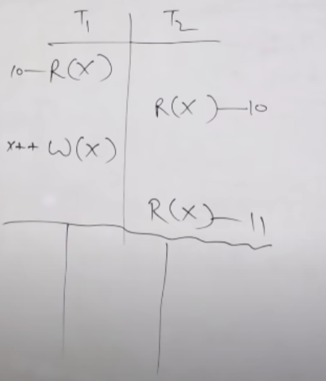

**Phantom Read Problem**

When two transactions are running at a single time, and one transaction reads the value of a variable from other transactions, if at first time, one transaction is able to read the variable value but in the next time, the data doesn’t exist, it is called phantom read.

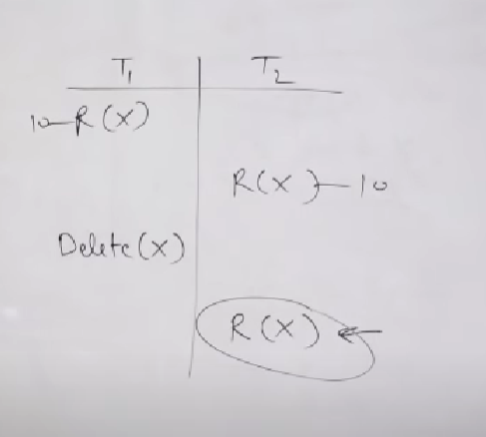

**Lost Update Problem :**

When a transaction directly writes without reading , it is called blind write. When two transactions are running at a single time, when the other transaction writes the value of a variable without reading it, it is called lost update problem.

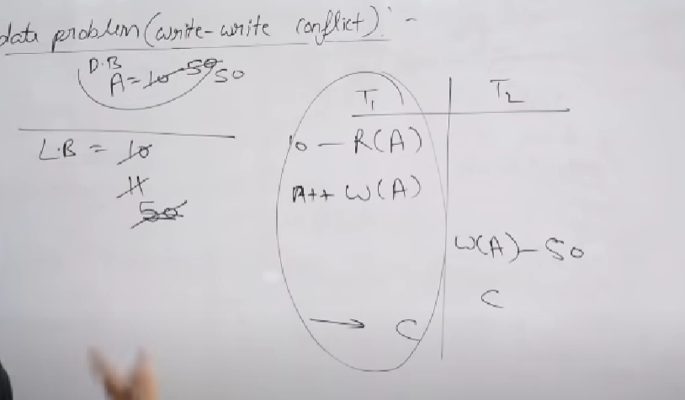

**Schedule :**

It may be defined as the hard unit of execution having concurrent transactions.

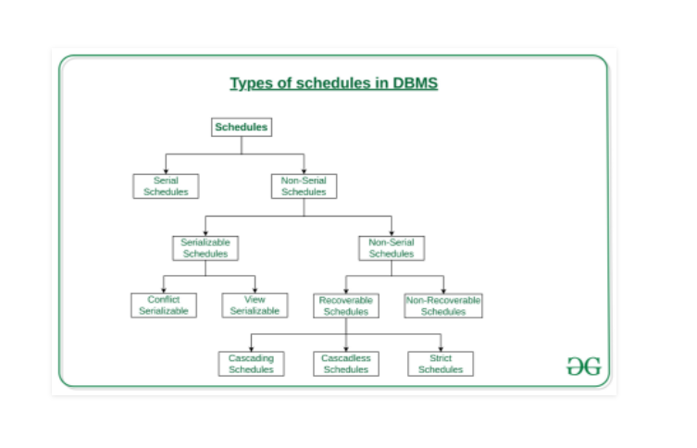

Serial Schedule :

When one transactions starts execution after the completion of another transaction , then, it is called serial schedule.

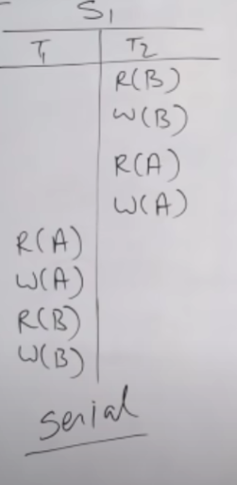

Non-Serial Schedule :

When there is a context-switching between two concurrent transactions in a schedule, then , it is called non-serial schedule.

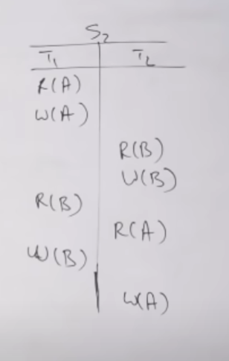

**Conflict Serializable :**

When a non-serial schedule can be converted to serial schedule by swapping of non-conflicting transactions , then, it is said to be conflict serializable.

Conflicting transactions :

* They belong to different transactions
* They operate on same data item
* At least one of them is a write instruction

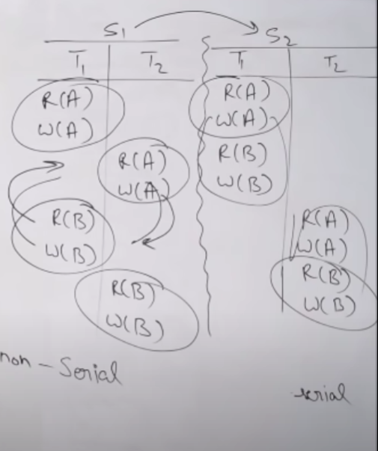

**View Serializable**

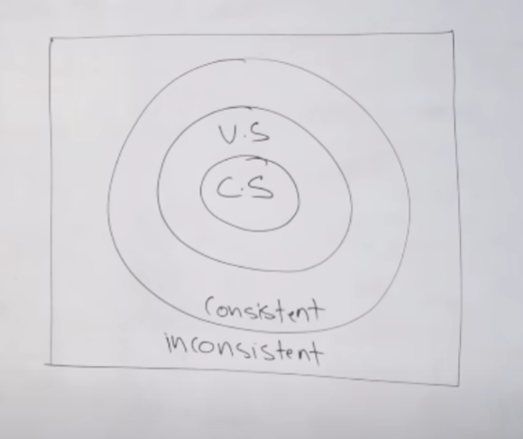

**Recoverable Schedule :**

Even if the serial schedule are consistent, but due to some failure in one of the transactions, it can take schedule to ir-recoverable state(inconsistent state from where we can’t come back).

It happens whenever there is dirty read and the dependent transaction commits first before the independent one. The solution for this problem is that the dependent transaction should always commit later than the independent one.

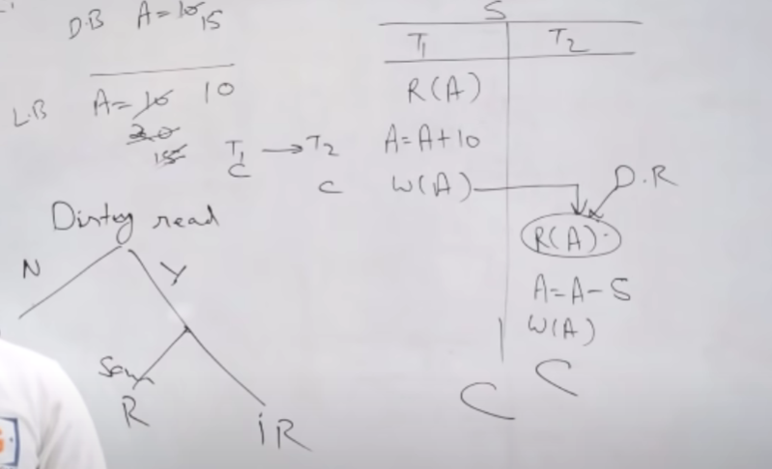

**Cascadeless Schedules :**

Whenever there is dirty read, it’ll always be cascade rollbacks, but it may or may not be recoverable.

Cascasde rollbacks may be defined as the rollbacks which one transaction seeing at the other transactions.

We can achieve cascadeless schedules by committing every change for each transaction before it can be read i.e avoiding dirty read conditions but it decreases the degree of concurrency.

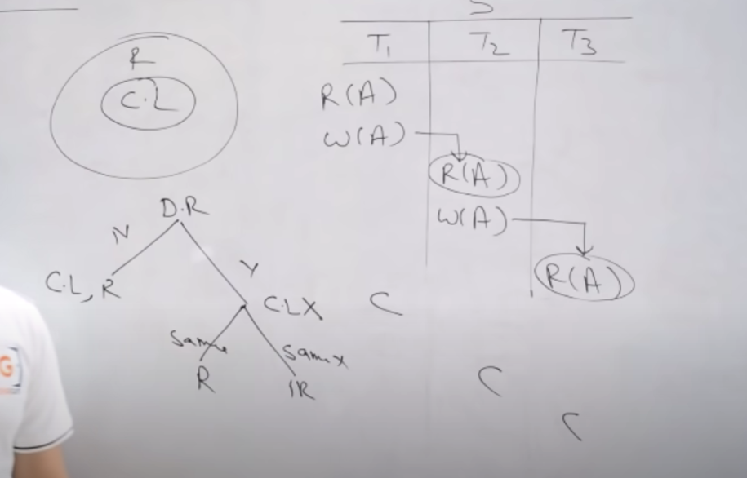

**Strict Schedule :**

Cascade schedule has the issues with dirty read. But there can be transactions when there is blind write and still the schedule is cascadeless schedules.

As per strict schedule, one transaction can read the value of a resource from other transaction only in case the other transaction has committed the value for that resource.

